1. **Daily notes.**

**Constructor**

* Constructor is a block of code like a method
* It is not a return type
* It is specified form of class to initialize the object
* Constructor is invoked when a new object of its class is created
* Every class has a constructor taken as default
* Constructor is called when instance of the call is created

Example:

Public class student{}

Student() // this is constructor

**Type of Constructor**

Default constructor _ default null

Parameterized constructor _ public student (int,int) To provide Different values to distinct object

No Argument constructor _ public Student()

1. **Interview questions**
2. **Difference**
3. Example program for method overloading (add method)

1. int int

2. int float

3. int int int

4. int float int

5. float float

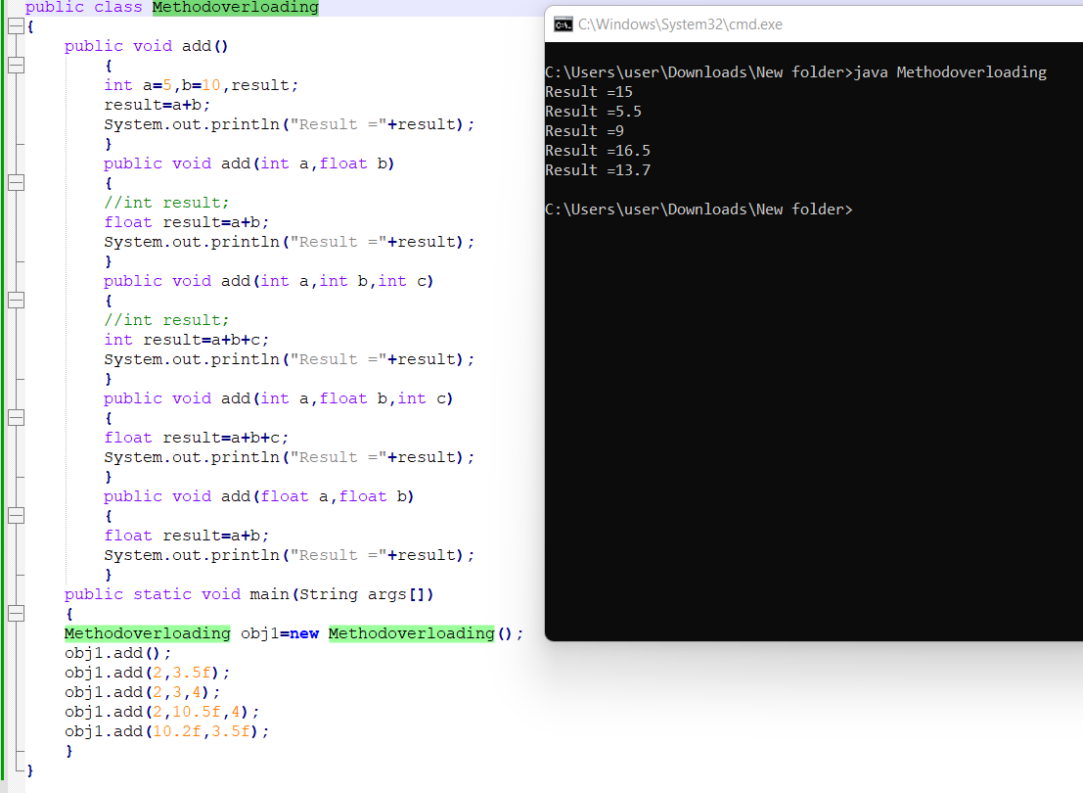

1. Write a program to find the
2. Average of three integer numbers, three float numbers(should have same method name)

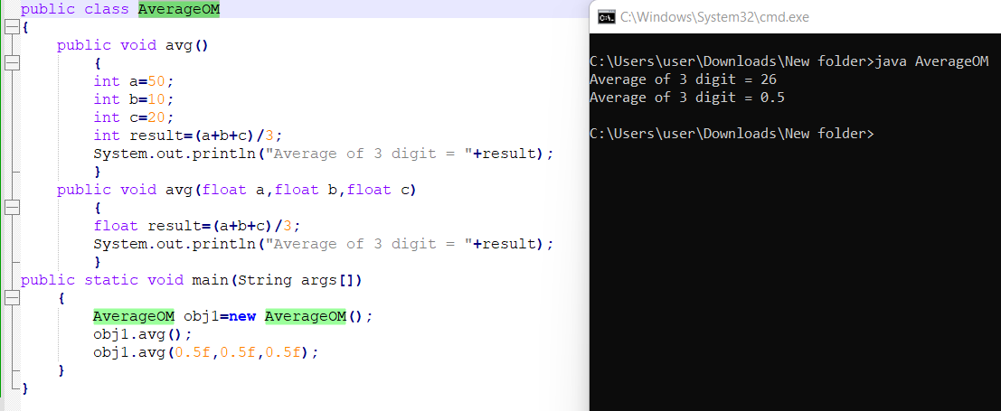

1. Area of figures(circle, rectangle, square) by using three methods(should have same method name)

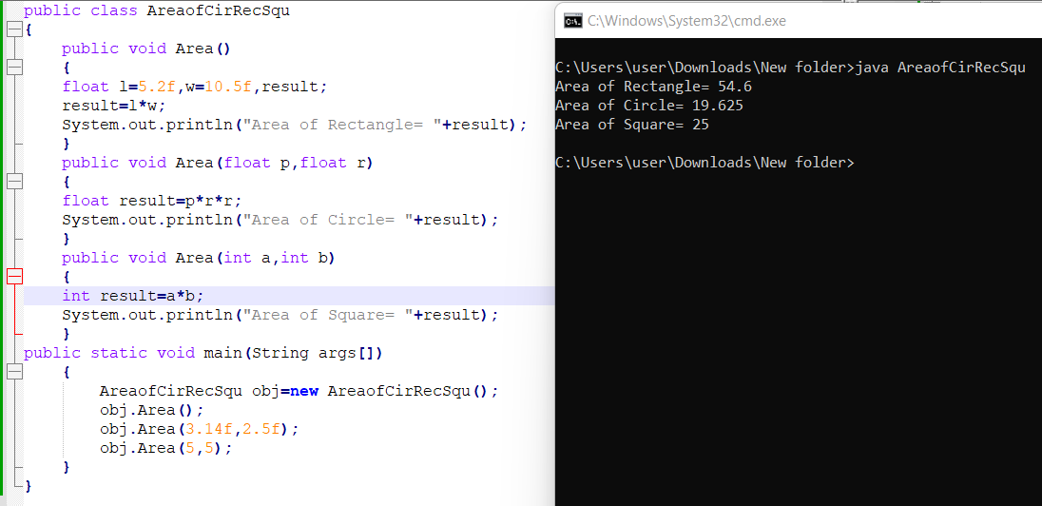

1. Write a program to find the grade of 2 students based on total marks(3 subjects)

• Get the student’s marks by constructor

• Return total mark to in main method

• Find the grade of each student.

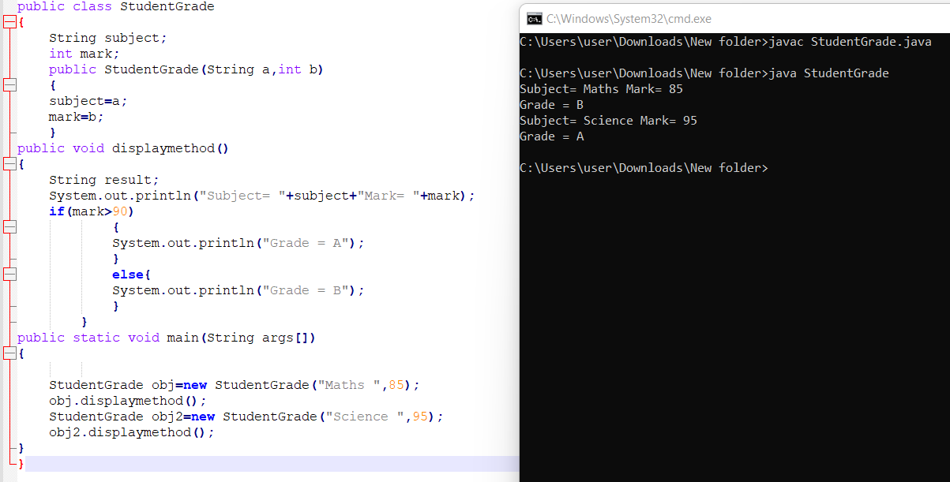

1. Program to learn this keyword

[ this() :to invoke current class constructor ]

**Write a program to call no agr constructor from parameterized constructor:**

**Write a program to call parameterized constructor from no agrs constructor:**

